

Master MLDM and COSI - Computer Vision course

_________________________________________

Correction Exam March 2023 - 1h30 without documents

__________________________________________

Part 1 (5 points): Stereo correspondence

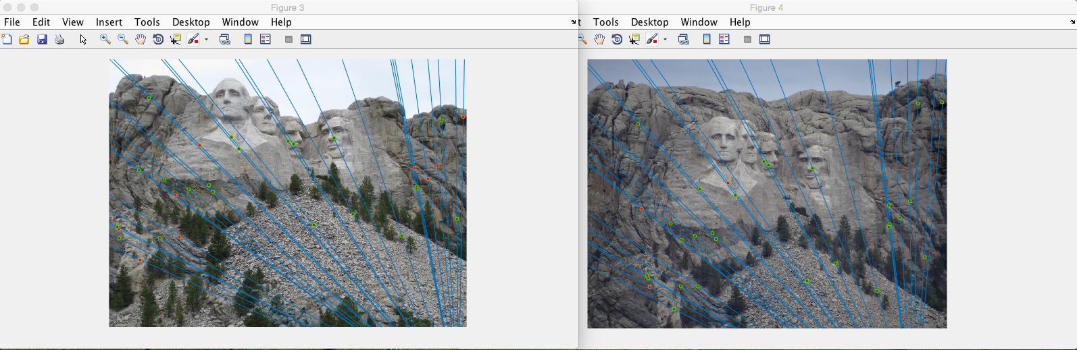
(a) left view (b) right view

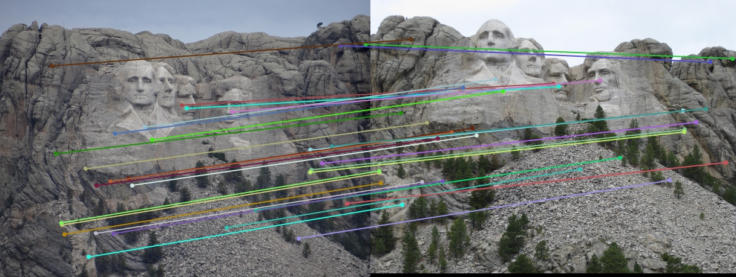
(c) Examples of corresponding points

Figure 1: Example of pairs of stereo images.
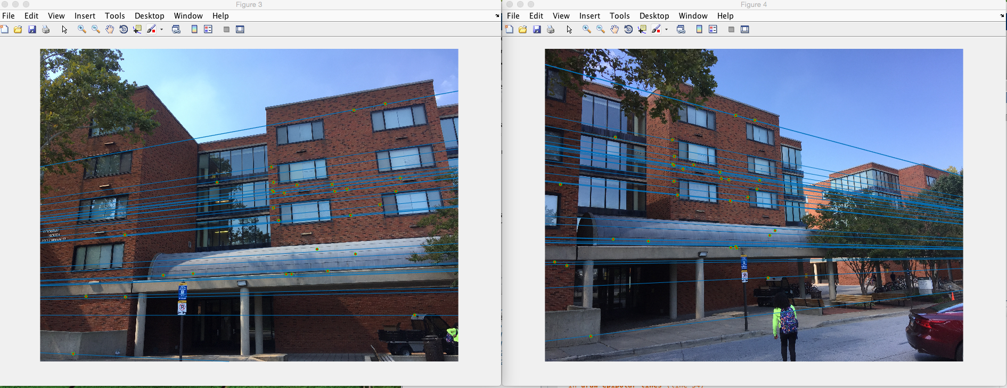
(a) left view (b) right view

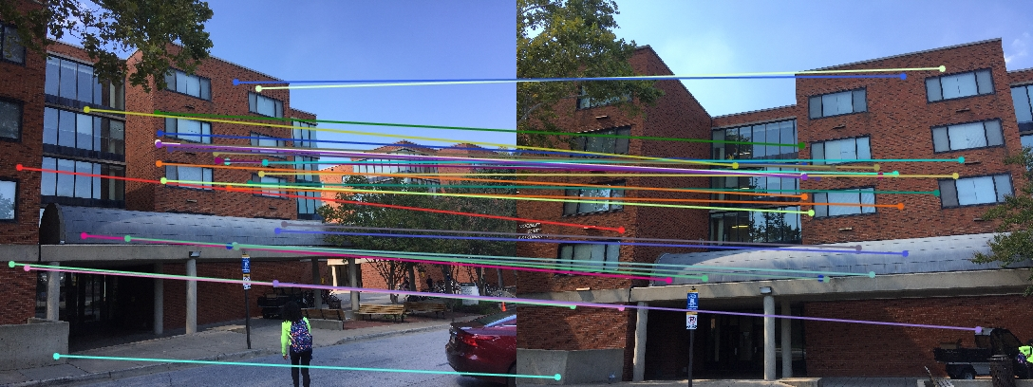
(c) Examples of corresponding points

Figure 2: Example of pairs of stereo images.

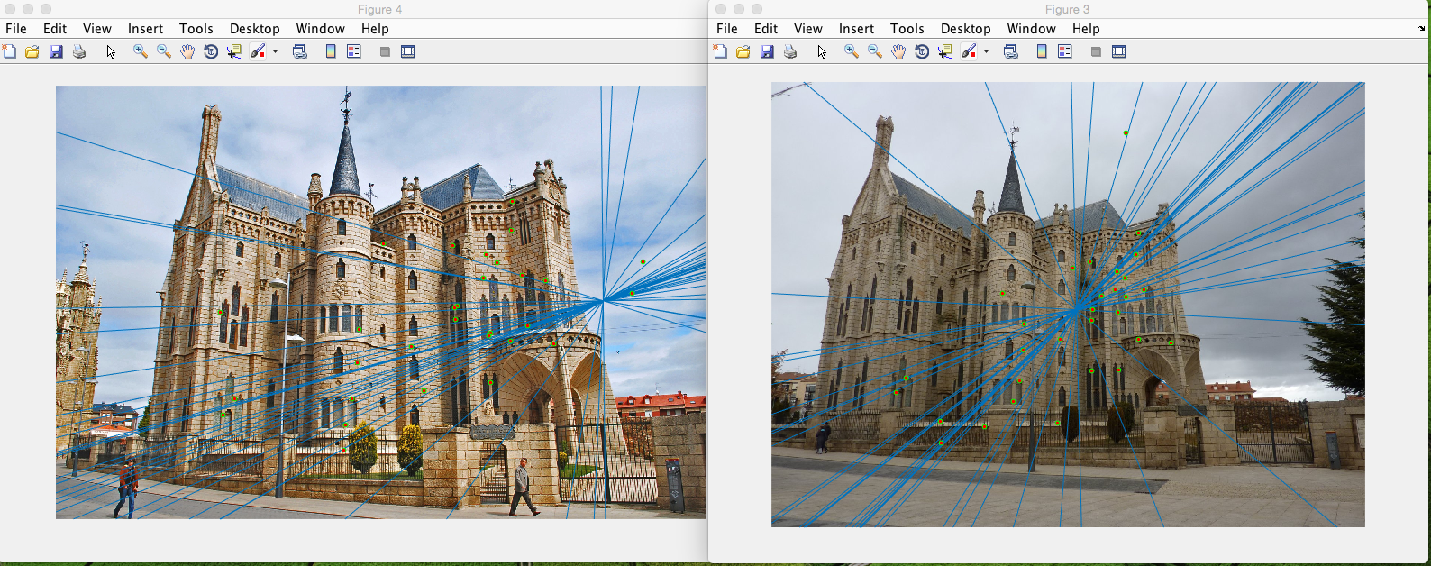
(a) left view (b) right view

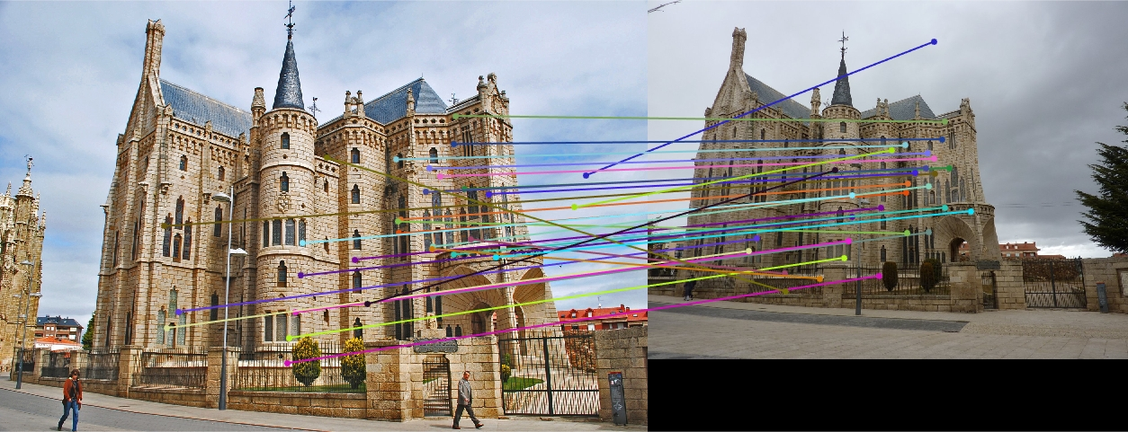
(c) Examples of corresponding points

Figure 3: Example of pairs of stereo images.
Question 1 (2 points): In Figures 1 to 3, what do represent blue lines in images (a) and (b)? What these lines tell us?

Answer: they corresponds to the epipolar lines associated to key points. On each figure epipolar lines intersect that means that the stereo images are not rectified. The location of the intersection point inform us on the relative position/viewing direction of each camera of the stereo setup.

Question 2 (2 points): In Figures 1 to 3, what do represent color lines in images (c)? What these lines tell us?

Answer: they inform us about which kind of transformation (rotation and/or translation and/or scaling) was applied to corresponding points. For example, in case of XY translation all these lines should be parallel. The disparity map between left and right views enables us to compute the depth.

Question 3 (1 point): What is the main interest of the epipolar geometry in stereo views matching?

Answer: it limits the research space (for matching task) to 1 dimension

see https://www.cc.gatech.edu/classes/AY2016/cs4476_fall/results/proj3/html/adas62/index.html

Part 2 (3 points): Stereo correspondence
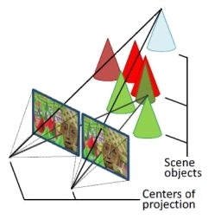



(a) Middlebury stereo image “cones” (b) left view

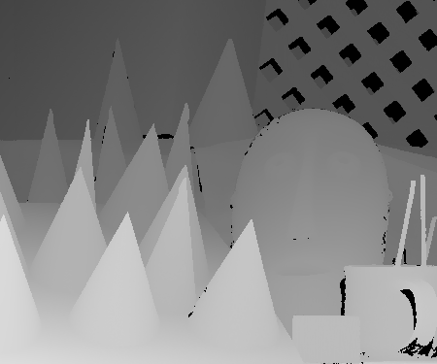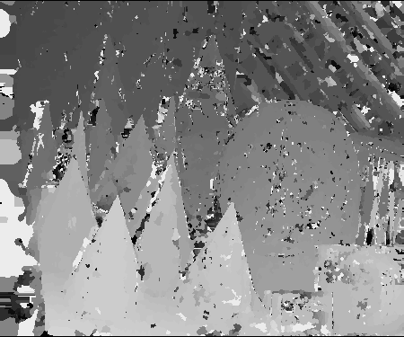
(c) Disparity map (ground truth) (d) Disparity map computed from stereo matching

Figure 4: Example of pairs of stereo images.

Question 4 (2 points): In Figure 4 (c), what does represent the disparity map? Why stereo matching methods based on local spatial correlation technique cannot perform well on such image (see Fig. 4 (d)).

Answer : the disparity maps inform us about the depth of objects. Stereo matching methods based on correlation cannot perform well on repetitive patterns and textureless areas. Furthermore, when the size of the correlation window is too small the disparity map is noisy.

Question 5 (1 point): It seems in Fig 4 (b) that all cones have the same size, does this assumption is true?

Answer : The ambiguity that we have with monocular vision regarding the size/height of objects can be solved with stereo vision.
The estimation of the size of an object is inversely proportional to the depth, so it’s possible that the farthest cones have a higher size than the closest.

Part 3 (5 points): Epipolar geometry

The camera projection matrices of two cameras (given in the coordinate system attached to the first camera) are
C = [I 0] and C’ = [R t]
where R is a rotation matrix and t = (t_{x}; t_{y}; t_{z}) describes the translation between the cameras. Hence, the cameras have identical internal parameters and the image points are given in the normalized image coordinates (the origin of the image coordinate frame is at the principal point and the focal length is 1).

The epipolar constraint is illustrated in the Figure 5 below and it implies that if p and p’ are corresponding image points then the vectors 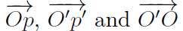 are coplanar.
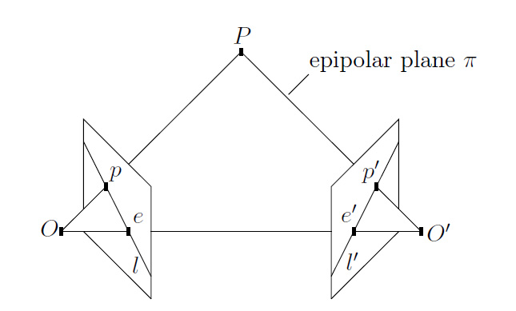
Figure 5: Epipolar geometry. Given a point p in the first image its corresponding point in the second image is constrained to lie on the line l’ which is the epipolar line of p. Correspondingly, the line l is the epipolar line of p’. Points e and e’ are the epipoles.

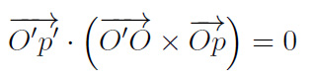
Consequently: (1)
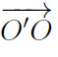
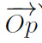
with x represents the cross product between vectors and
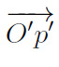
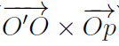
and . represents the inner product between vectors and

Let p = (x; y; 1)^{T} and p’ = (x’; y’; 1)^{T} denote the homogeneous image coordinate vectors of p and p’.

Questions 6 (2 points): Show that the equation (1) can be written in the form:
p’ ^{T} E p = 0 (2)
where matrix E is the essential matrix defined by: E = [t] R

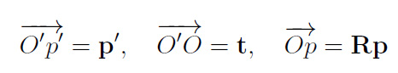
Hints:
In the coordinate system of the second camera we have:
The cross product b x a, of two arbitrary 3D vectors a = (i; j; k)^{T} and b = (l; m; n)^{T}, can be written as:
0 –k j l
a x b = k 0 –i m = [a] . b
-j i 0 n

where [a] is a 3x3 skew matrix associated to the vector a.
Answer: by substituting into (1) we get: p’^{T} (t x Rp) = 0
- p’^{T} ( [t] R p ) = 0
1x3 3x3 3x3 3x1 = 1x1

- p’^{T} ([t] R) p = 0
1x3 3x3 3x1 = 1x1
- p’^{T} E p = 0

Question 7 (1 point): How can the epipolar constraint be utilized when searching point correspondences between two views?

Answer: Given a point in the first image and the epipolar geometry one may directly compute the corresponding line in the second image. Hence, it is sufficient to search the corresponding point in the neighborhood of this line and this significantly reduces the search area.

Question 8 (2 points): Let
1 0 0 1
R = 0 0 –1 and t = 1
0 1 0 1
be the rotation and translation between two views. Compute the essential matrix and the epipolar line which corresponds to the principal point of the first image (i.e. the point (0; 0) in the normalized image coordinate system).

Answer:
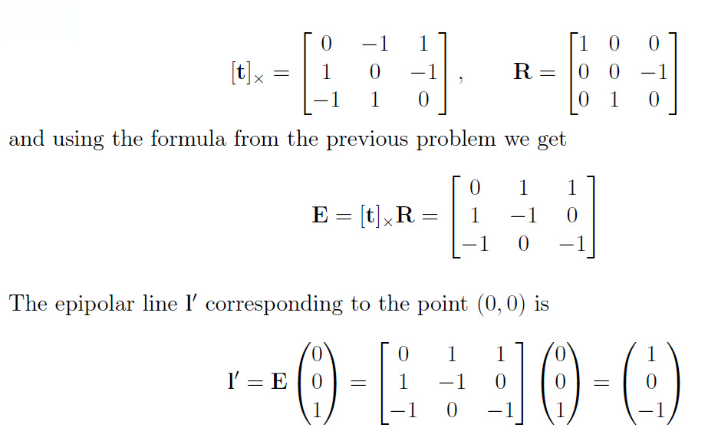

Part 4 (4 points): Accuracy of stereo systems
Consider the stereo system as displayed below. Or and Ol denote the optical centers of both camera systems. T is the baseline of the stereo system, i.e., the distance between the optical centers. P is a point which is projected onto its image point pr in the right camera and pl in the left camera. xr and xl denote the distance between the projections of P and the principal points of the cameras cr and cl.
The depth Z of P is computed as Z = f * T/d where the disparity d = xr - xl.
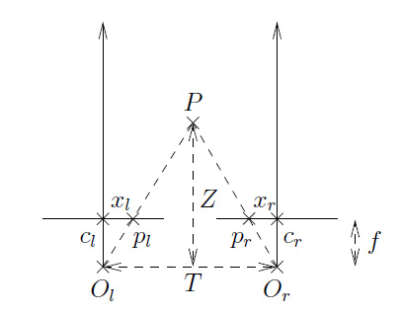
Question 9 (2 points): Estimate the accuracy of this stereo system assuming that the only source of noise is the localization of corresponding points in the two images. Discuss the dependence of the error in depth estimation as a function of the baseline width and the focal length.

Answer :
The two cameras of the stereo system are parallel and at the same distance along the Z axis, so the epipolar lines on the two images are aligned (no need to rectify the two images). Then the two points xr and xl which are localized on the same epipolar line are necessary at the same distance along the Z axis.
Therefore, the error in depth estimation (δ Z) depends only of the error in disparity estimation (δ d) as:
δ Z = f * T/ (δ d)

Question 10 (2 points): Using your solution to the previous question, estimate the accuracy with which features should be localized in the two images in order to reconstruct depth with a relative error smaller than 1%.

Answer:
The relative accuracy of x and y coordinates (between left and right images) is defined by:
δ d = f *T/ (δ Z)
with (δ Z) = 1%
then δ d = 100 *f *T

Part 5 (4 points): Epipolar geometry

Question 11 (2 points): Estimate the essential matrix between two consecutive images for a forward translating camera (see image below) . What is the equation of the epipolar line for the point p=[x y 1] ?
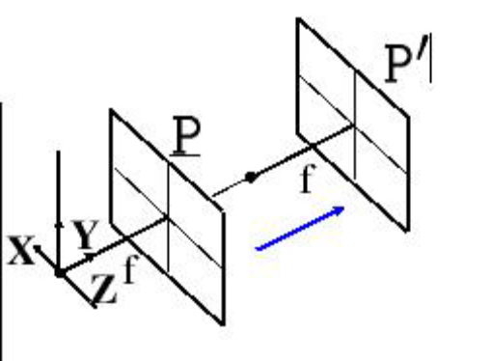

Solution:
In general E = t_{S} R
where t_{S} is a skew-symmetric matrix related to translation vector.
For a forward translating camera (see figure), we have:
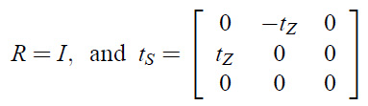
Therefore
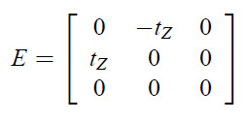
From l = E p the epipolar line for a point p = [x y 1] is:
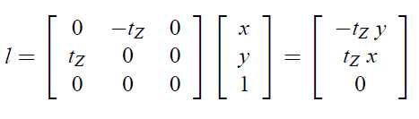

Question 12 (2 points): Assume a pair of parallel cameras with their optical axes perpendicular to the baseline. How do the epipolar lines look like? Where are the epipoles for this type of camera system?

Solution:
The epipolar lines are parallel to each other (also, in the direction of the image y axis). If the optical centers of the camera are on the same height, the corresponding epipolar lines will be on the same height - one line for both images. The epipoles are in the infinity.

See 521466S Machine Vision Exercise #7: Transformations and Epipolar geometry
Geometrically this means that given the point p the corresponding point p’ must lie on the line l’ = Ep.

